**Part 1 – MongoDB (CRUD and Simple Queries)**

Q1.

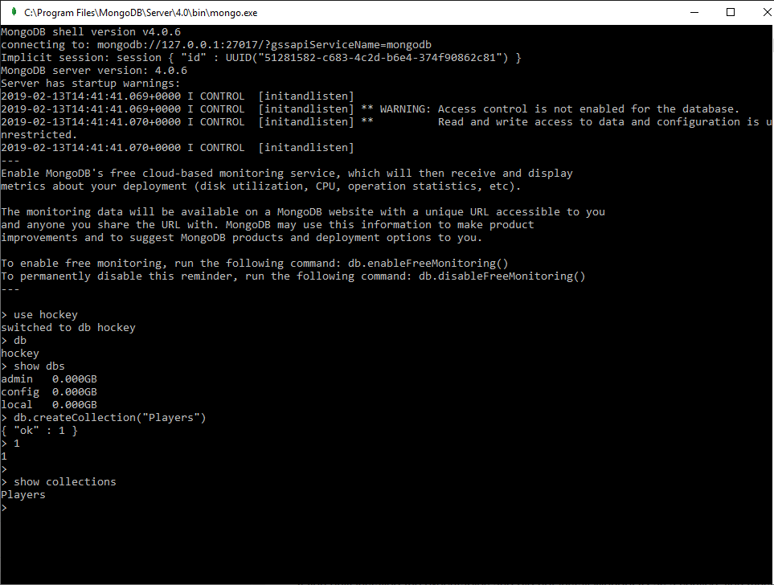

Q2.

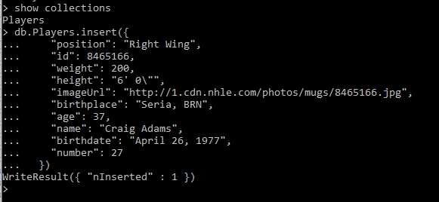

Q3.

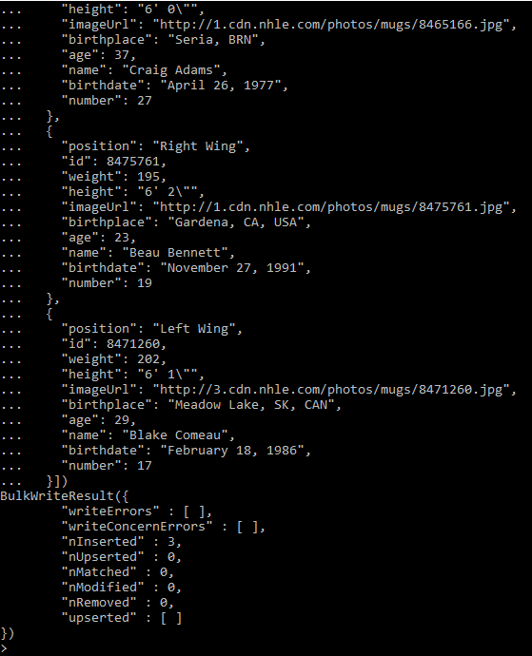

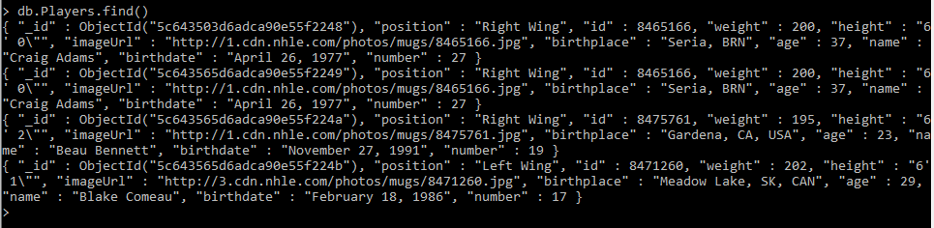

Craig has been inserted twice because MongoDB has automatically supplied a new primary key to the entries. As Craig Adams’s details were entered twice, there are now two entries with different ObjectIDs.

This problem can be fixed by manually assigning a number to “_id” when inserting data.

Q4.

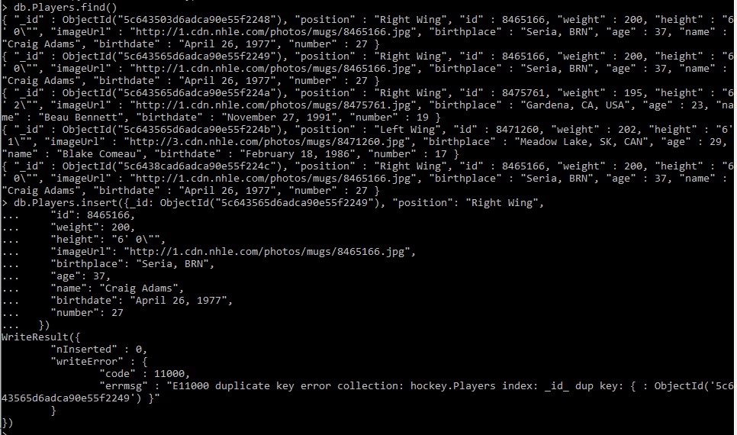

An error will appear as there is a duplicate primary key.

Q5.



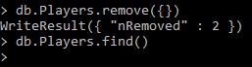

Q6.

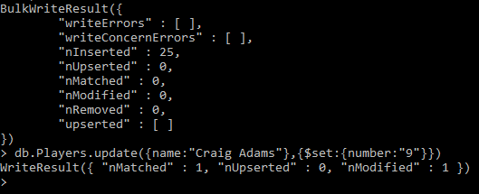

Q7.



Q8.

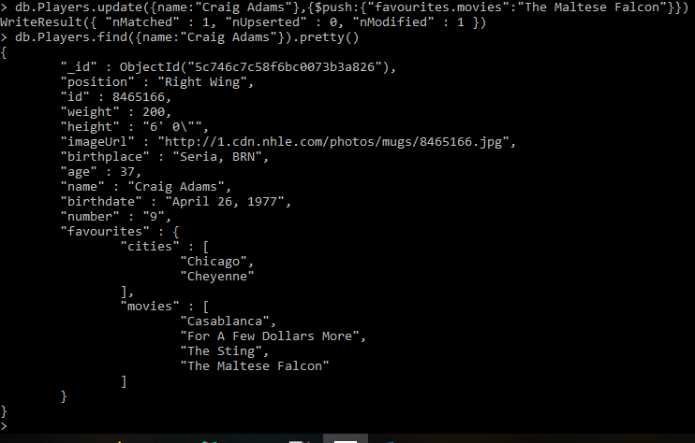

Q9.



Q10.

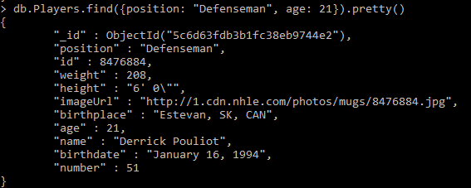

**Part 2 – MongoDB for Restaurants (Queries and Indexing)**



Q1.

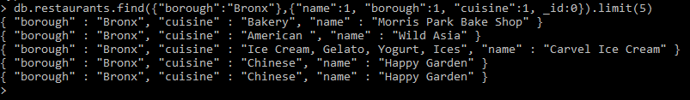

Q2.

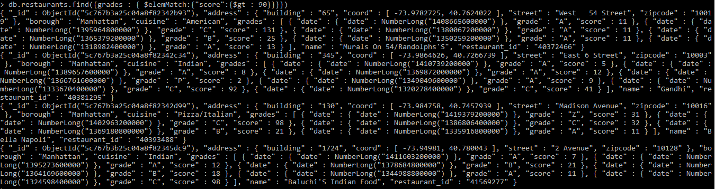

Q3.

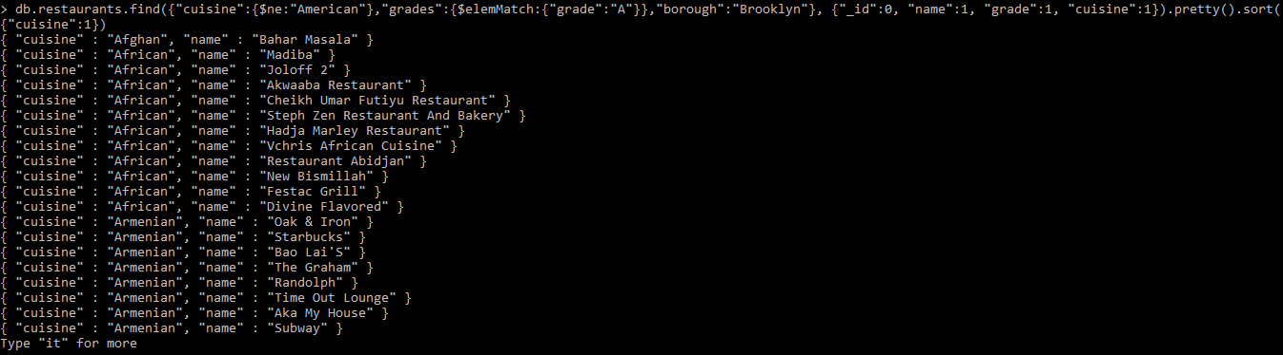

Q4.

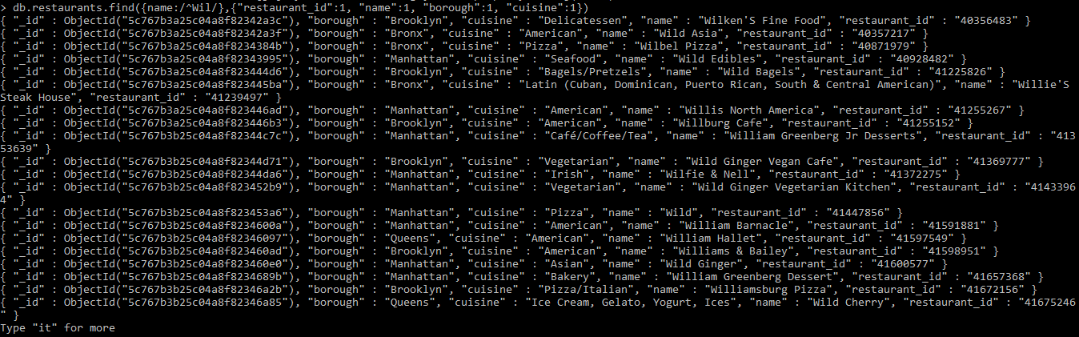

Q5.

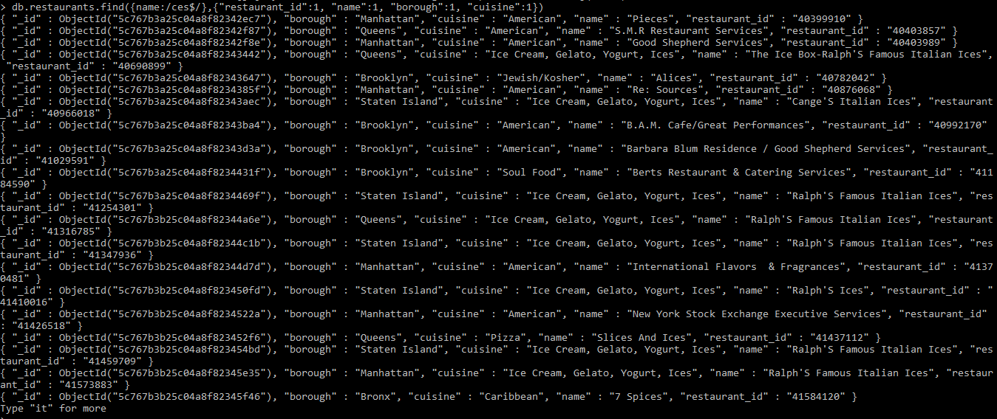

Q6.

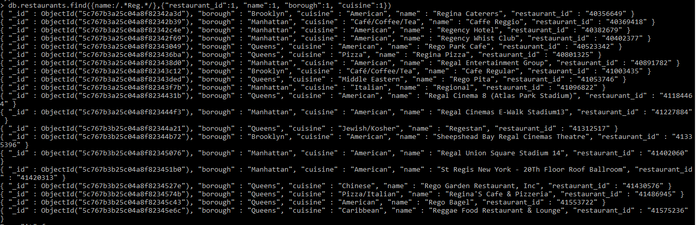

Q7.

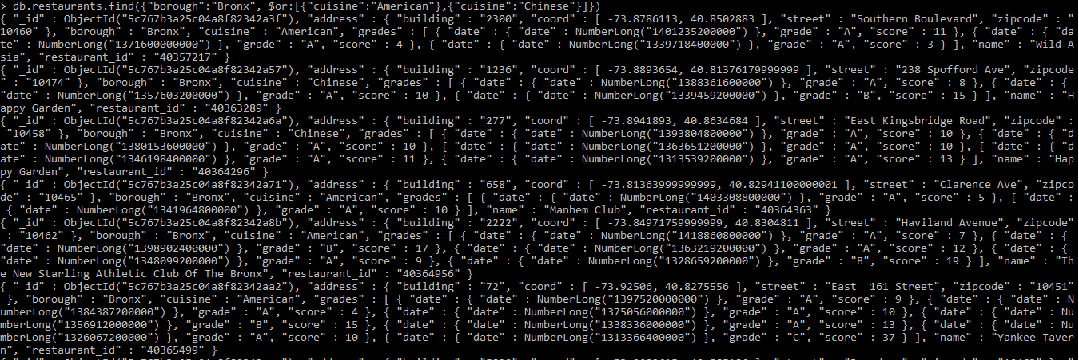

Q8.

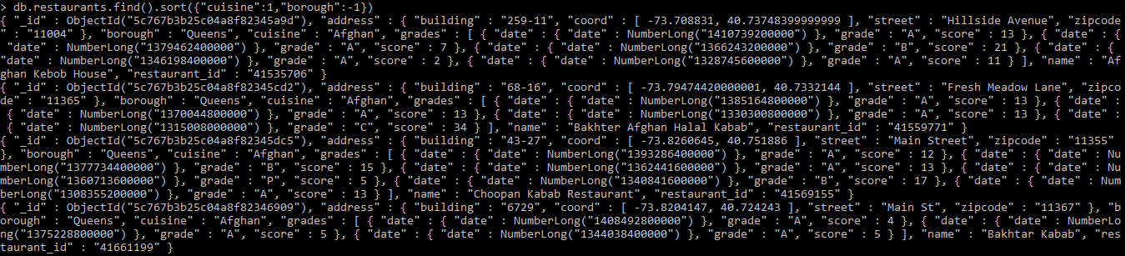

Q9.

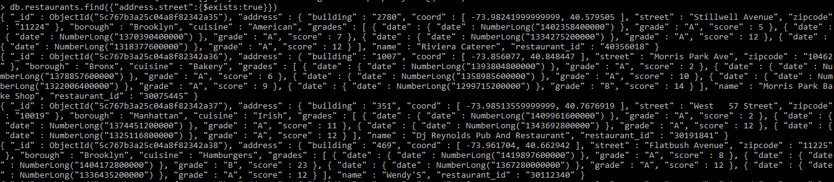

Q10.

